GENERATIVE AI ECOSYSTEM

Part 1: Hugging Face (The App Store of AI)

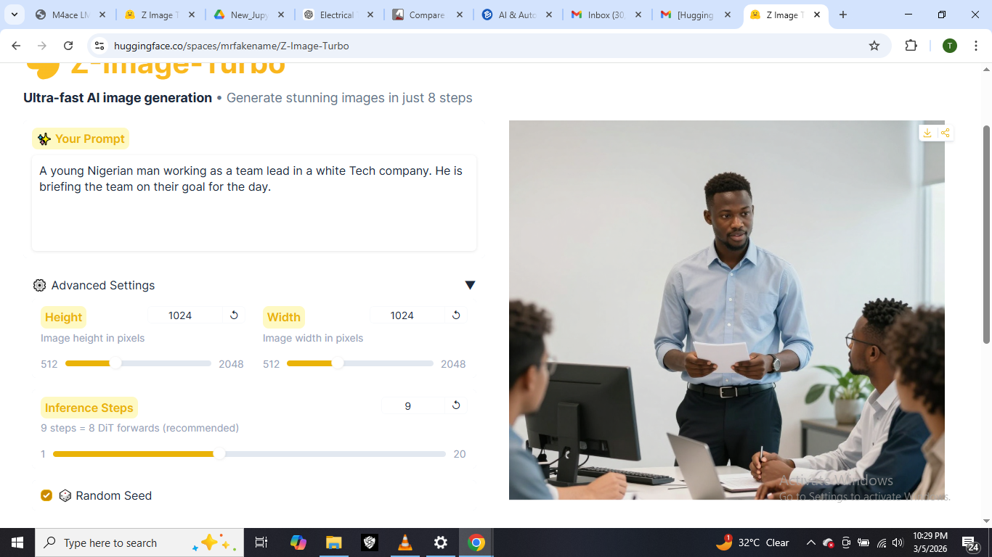

Part 2: Kaggle

The URL link to that dataset;
https://www.kaggle.com/datasets/pandeymritunjay/amazon-reco-ds
My Dataset of interest is “Amazon Fashion Recommendation”
Having robust data on all kinds of fashion ideas from Africa throughout Europe and the Antarctica would help the AI give unlimited recommendations and suggestions based on any location provided or identified.

Part 3: Google Collab (Your First AI Workspace)
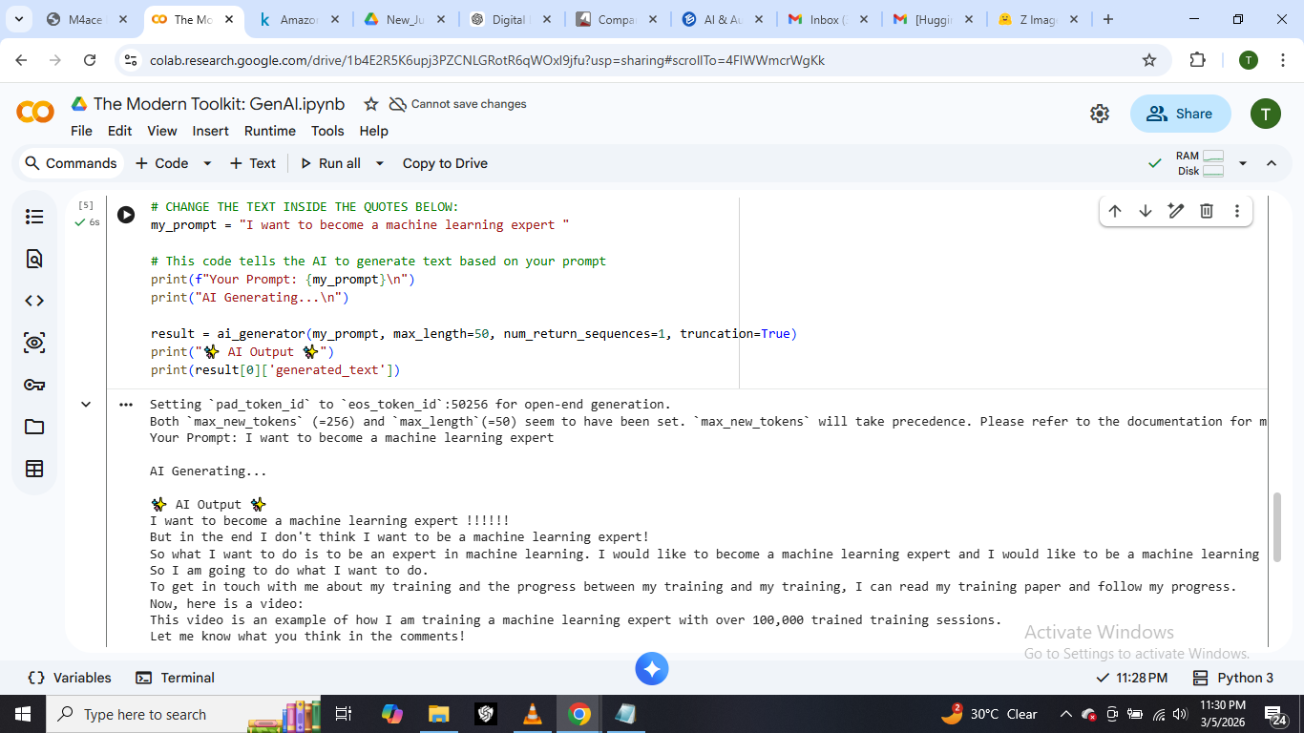

Part 4: GitHub (Your Digital Portfolio)
The URL of my new public GitHub repository;
https://github.com/Temitope2216/ML-AI-M4ACE

